**1** Are each of the statements true or false?

**a)** Elements are made up of one type of molecule.

**b)** The nucleus of an atom contains protons and electrons.

**c)** A proton has a positive charge.

**d)** An electron is much smaller than a proton.

**e)** The number of protons equals the number of electrons in an atom. (5)

**2** **a)** What is meant by the atomic number of an element? (1)

**b)** The chemical symbol for chlorine can be written as

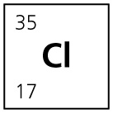

**i)** Explain what the number 35 represents. (1)

**ii)** What does the number 17 represent? (1)

**iii)** Fill in the gaps in the statements about the chlorine atom.

**A** There are ………… protons.

**B** There are …………. neutrons.

**C** There are ………….. electrons.

**D** The mass number is ……………… . (4)

**c)** Explain why a chlorine atom is neutral. (2)

**d)** Explain what is meant by the term isotope. (1)

**e)** Chlorine-35 and chlorine-37 are both isotopes of chlorine.

**i)** What do these isotopes have in common? (1)

**ii)** Explain how the two isotopes differ in terms of the number of protons and neutrons. (2)

**3** Many famous scientists have carried out work on the nature of the atom. The contributions below are mismatched. Draw an arrow from each scientist to his actual discovery.

|  |  |
| --- | --- |
| Scientist | Contribution |
| Niels Bohr | Atoms are small non-divisible particles. |
| Ernest Rutherford | An atom is a ball of positive charge with electrons dotted around inside it. |
| Democritus | Discovered neutrons in an atomic nucleus. |
| J.J. Thompson | Electrons move around the atomic nucleus in circular orbits. |
| James Chadwick | The positive charge of an atom is in the nucleus with the electrons outside balancing the charge. |

(5)

**4** Some elements will emit particles in order to make the nucleus more stable. These radioactive elements vary in the nature of the particle they emit. There are four types of radioactive emission.

**a)** Alpha and beta particles are two types of radioactive emissions. Name two others. (2)

**b)** Complete the table by filling in the gaps.

|  |  |  |  |
| --- | --- | --- | --- |
|  | **Type of decay** | | |
| **Change in number** | **Alpha decay** | **Beta decay** |  |
| protons |  |  | 0 |
| neutrons |  |  | –1 |

(3)

**c)** Complete the equations below to show the result of different emissions.

**i)** Uranium-230 loses an alpha particle  
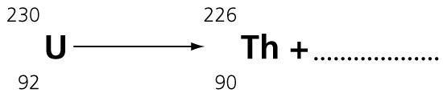 (2)

**ii)** Carbon-14 loses a beta particle   
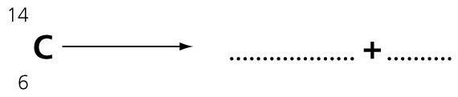 (3)

**5** The body can be damaged when it comes into contact with radiation.

**a)** Name the emission that causes the most damage to body tissues and explain why. (2)

**b)** Which type and thickness of material is needed to prevent the passage of:

**i)** alpha rays? (1)

**ii)** gamma rays? (1)

**c)** Describe how radiation in the environment is detected and measured. (4)

**6** The diagram shows a positively charged gold leaf electroscope.

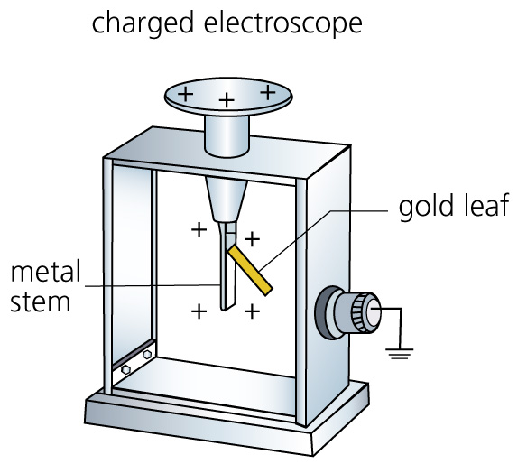

**a)** Describe and explain how the strip of gold leaf behaves when the electroscope is positively charged. (2)

**b)** The diagram now shows what happens to the charged electroscope when a radium source is held near. The radium source emits alpha particles.

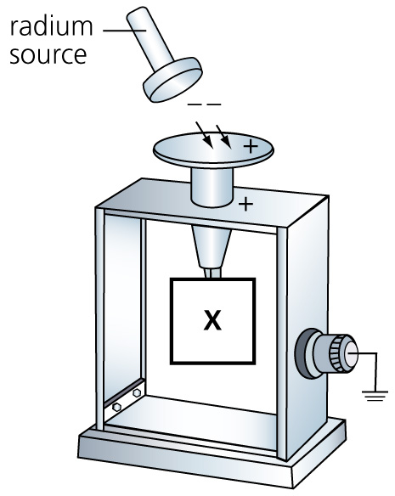

**i)** Describe what you would observe happening to the gold leaf behind X? (1)

**ii)** Explain the observation in terms of ionisation. (3)

**7** The graphs in the diagram show the decay of three different radioactive isotopes.

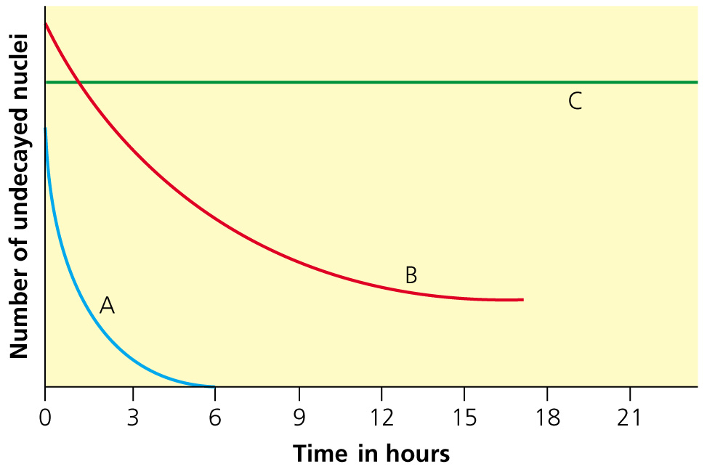

**a)** Which isotope has

**i)** the longest half-life? (1)

**ii)** the shortest half-life? (1)

**b)** Which isotope could be used as a medical tracer? Explain your answer. (2)

**c)** A radioactive isotope called technetium-99 has a half-life of 6 hours. At 12 noon on

1 February, a GM tube measures a count rate of 2400 per second.

**i)** What will the approximate count rate be at 3.00 am on 2 February? (1)

**ii)** At what time will a count rate of approximately 75 per second be measured? (1)

TOTAL = 53

**1** **a)** False

**b)** False

**c)** True

**d)** True

**e)** True (5)

**2** **a)** The number of protons in the nucleus of an atom. (1)

**b)** **i)** Mass number; number of protons plus neutrons in an atom. (1)

**ii)** The atomic number; the number of protons in the nucleus.

**iii)** **A** 17

**B** 18

**C** 17

**D** 35 (4)

**c)** The number of protons (positively charged particles) is equal to the number of electrons (negatively charged particles); the two charges balance each other. (2)

**d)** Isotopes are different forms of the same element. They have the same number of protons but different numbers of neutrons. (1)

**e)** **i)** They both have the same atomic number of 17. (1)

**ii)** Cl-35 has 18 neutrons; Cl-37 has 20 neutrons. Both have 17 protons. (2)

**3**

|  |  |
| --- | --- |
| Scientist | Contribution |
| Niels Bohr | **Electrons move around the atomic nucleus in circular orbits.** |
| Ernest Rutherford | **The positive charge of an atom is in the nucleus with the electrons outside balancing the charge.** |
| Democritus | **Atoms are small non-divisible particles.** |
| J.J. Thompson | **An atom is a ball of positive charge with electrons dotted around inside it.** |
| James Chadwick | **Discovered neutrons in an atomic nucleus.** |

(5)

**4 a)** Gamma radiation and neutrons. (2)

**b)**

|  |  |  |  |
| --- | --- | --- | --- |
| Change in number | Alpha decay | Beta decay | Neutron decay |
| protons | **–2** | **+1** | 0 |
| neutrons | **–2** | **–1** | –1 |

(3)

**c)** **i)**  (2)

**ii)**  (3)

**5** **a)** The most damaging radiation is the alpha particle; the alpha particle does not travel far in body tissues; it transfers its energy in a very small space but this causes great damage to localised tissue. (2)

**b)** **i)** Paper sheet or thin fabric (1)

**ii)** Thick lead (1)

**c)** Geiger Muller tube detects ionising radiation. An electronic counter records the number of particles entering the tube.

The background count is the average count rate recorded by the GM tube. The background count is caused by radioactive materials such as radon in the environment. (4)

**6** **a)** When the electroscope is positively charged the metal stem is positively charged. The gold leaf is also positively charged. The gold leaf sticks out away from the metal stem because like charges repel each other. (2)

**b)** **i)** The gold leaf moves towards the metal stem. The electroscope has been discharged. (1)

**ii)** Radium emits alpha particles. The alpha particles create negative and positive ions in the air around the electroscope. This is called ionisation. Negative ions are attracted to the positively charged electroscope. The charge on the electroscope is neutralised. (3)

**7** **a)** **i)** C (1)

**ii)** A (1)

**b)** A; shortest half-life means it will remains radioactive for the least amount of time so causing least damage to the body. (2)

**c)** **i)** 450 (1)

**ii)** 6 p.m. 3 February. (2)

TOTAL = 53